DOCUMENTATION

Definitions for each response categories:
Final Categories | Working definition
Growth | Changes in body size, length, mass, biomass, or growth rate.
Development | Progression through life stages, timing of development, morphology, abnormalities, or settlement.
Physiology | Metrics that reflect internal functioning, organism condition, or observable activity, including metabolism, respiration, enzyme activity, oxidative stress, calcification, shell condition, energy reserves, swimming activity, feeding behaviour, predator avoidance, and movement.
Reproduction | Responses related to reproductive output or investment, including fecundity, egg production, spawning, fertilisation success, gonad condition, reproductive effort, and hatching success.
Survival | Persistence, mortality, abundance, density, or population/count-based endpoints.

META-ANALYSIS REFERENCES:
Methodologies:

- Alter et al. 2024: Invertebrates Dataset
- Filter all columns > Go to LifeStage > and only enable EMBRYO, LARVA, AND POSTLARVA
- In the column Include, enable only “in”

Alter et al. 2024: Fish Dataset
- Filter all columns > Go to LifeStage > and enable EMBRYO
- In the column Group, only enable Fish as elasmobranch are not planktonic at all in all of its life stages

- Jian et al. 2022

For zooplankton:
- Filter columns > Ecosystem_category == Marine > Biota_Group == Zooplankton (retrieved 350)
- One entry under Towle, Erica K. et al., 2016 was categorised under Zooplankton but was transferred to Meroplankton (349)

For fish and invertebrae:
- Filter columns > Ecosystem_category == Marine > Biota_Group == Fish & Invertebrae (retrieved 259)
- For these remaining studies, look at first whether they already exist in Alter or not. If not:
- Check whether the reference studied meroplankton stage or not (look up the study itself). If they did not look at meroplanktonic stage, on the link column, note this down.
- Moreover, exclude juveniles (i.e., Kikkawa et al. 2003)
- Using this schematic, only 127 retrieved.
- Since Hoshijama U et al. 2017 look at pteropods, this was transferred to holoplankton, thus the remaining retrieved entries is just (123)

- Hoppit et al. 2022
- Filter columns > In the column taxonomy, disable the following: Seagrass, Algae, calcifying algae => 514 studies
- Under organism, look up which species are holoplanktonic and enable them only, and this include the following (29) 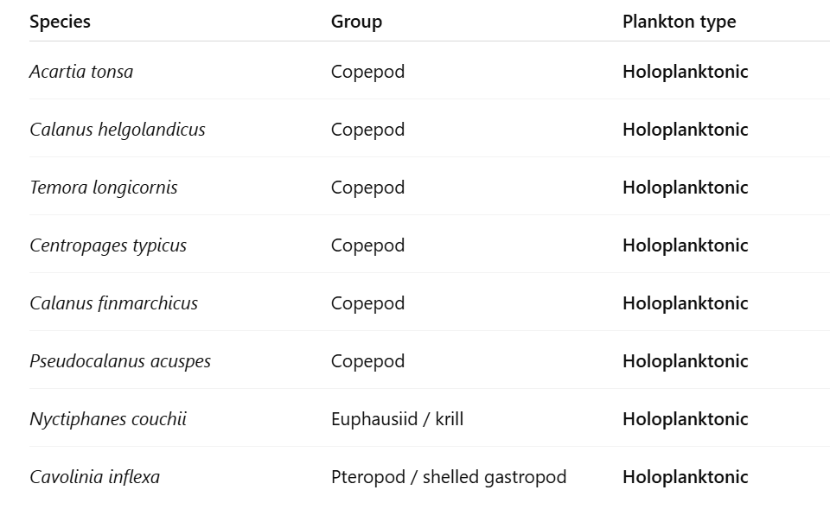
- Then check whether each of these already exists in the current database => all are new (29)
- Now, under organism, disable all the holoplanktonic species, and then under the column dev_stage, disable the adults and juvenile and na (technically leave egg/larva) => 85
- Then check whether these studies are new
- The new ones => 55
- Thus, the total for Hoppit et al. combined is 84.

- Hu et al. 2024
- Filter columns > Go to LifeStage and enable embryo, egg, fertilization and larvae => 150 records
- Go to species column and identify which species don’t undergo planktonic stage and disable them => strict no include Sepia officinalis and Macrocystis spp. => 141 records remain
- Manually check whether such studies already exist in the database or not. If they already exist drop them => 51 records remain
- Now, clear all filters, and then go to species section, identify which species are holoplanktonic => Limacina spp., Neogloboquadrina, and marginopora => 12 records
- Identify whether they are new records or not => 12 records remained
- In total, 51 + 12 => 63 records retrieved

- Kindinger et al. 2022
- Filter columns > Go to Cons_taxa spec and then enable only those holoplanktonic species, which include these:
  - Copepod
  - Krill
  - Ciliate
  - dinoflagellate
- This results to 28 retrieved entries. Then identify what’s new => 24
- Then remove filter, and then got to Cons_taxa spec again, and then try to enable everything except for the holoplanktonic taxon groups and then under cons_lstage category, select larv => 32 entries, then check whether new => 20
- In total, 24 + 20 => 44 entries

- Kruft-Welton et al. 2024
- Filter columns > Go to developmental_stage == Egg/larva => 45 entries
- Check if new => 42 entries

- Lang et al. 2023
- Filter columns > Lifestage > select embryonic, larval, and gametes => 295 entries
- manually check if study already exists in the database (in reference to Alter et al.) => 242 entries

- Ross et al. 2024
- Standard protocol: Go to Life_stage > enable larval only > and then manually check if data already exists
- There are four spreadsheets
  - OA_Data_Size => 60 entries
  - OA_Mortality => 45 entries
  - T_Data_Size => 19 entries
  - T_Mortality => 37 entries

- Rynkowski et al.
- Filter columns > Life stage = larvae, embryo, gametes => 26 entries

- Hamraj et al. 2021
- There are several sheets in this database
- All the acidification related sheets are already reflected in Jian et al. 2025 => double checked and apparently not all the entries are reflected in Jian
  - Egg production => 79 records => 53 records after filtering out existing records
  - Survival => 22 entries => 3 entries
  - Respiration => 56 entries => 65 entries
  - Feeding => 26 entries => 17 entries
  - Egg hatching => 152 entries => 110 entries
- All the temperature related entries are new => 312 entries
  - Egg production => 121 entries
  - Egg hatching => 70 entries
  - Survival => 52 entries
  - Respiration => 46 entries
  - Feeding => 23 entries

- Leung et al. 2022
- Provided by the author himself
- Manually assigned the metric direction

META-ANALYSIS REFERENCES:
Assigning the direction of the response:

Following Alter et al. (2024), assigning the direction of response metric is important in correctly representing the log response ratios. Alter et al. (2024) used three categories: positive, negative, and ambiguous.

- Alter et al. (2024) for Invertebrates and Fish.
- They already had this column under MetricType.

- Jian et al. (2025)
- Column: Response_Biota, all of the metrics used across the studies were elaborate and detailed enough to assign the metrics accordingly to positive, negative, and ambiguous.

- Hoppit et al. (2022)
- Based on the column biologicalparameter
- However, the possible categories were just generic and general. For instance, growth, survival, reproduction, metabolic response, calcification, etc.
- Because of these, all of the records were assigned ambiguous.

- Hu et al.
- Based on the column CalculatedUnit
- Because the metrics were specific enough, they were assigned accordingly to positive, negative, and ambiguous
  - Generally, those assigned negative were mortality

- Kindinger et al. 2022
- Based on the column Resp_spec
- All of the metrics were assigned as positive since behavioural metrics are generally more positive, the higher the metric (e.g. higher ingestion rate == better)

- Kruft Welton et al. 2024
- Based on the column measurement
- All were assigned positive since all were growth-related metrics.

- Lang et al. 2023
- Based on the column Measure
- Because the metrics were specific enough, they were assigned accordingly to positive, negative, and ambiguous
  - Generally, mortality, abnormality, developmental length time were assigned as negative.

- Ross et al. 2024
- Since the study did not provide any response metrics, the individual records were revisited to determine the metrics that were used in the study (revisited manually)

- Rynkowski et al. 2025
- Based on the column Response.Measurement
- Since the metrics were just general, all were assigned as ambiguous

- Hamraj et al. 2021
- The study did not provide specific metrics used. Instead, they just divided their dataset by categories (as reflected in the different tabs in their spreadsheet)
- Some studies were revisited; others were not (revisited manually but not complete)

- Leung et al. 2022
- Author provided all the specific metrics used by each study
- Because the metrics were specific enough, they were assigned accordingly to positive, negative, and ambiguous

